DATA ANALYTICS WITH TABLEAU

ASSIGNMENT – 1

O.Kusuma

VNITSW

B.Tech(CSE)-4

20NN1A0536

1.BAR CHART

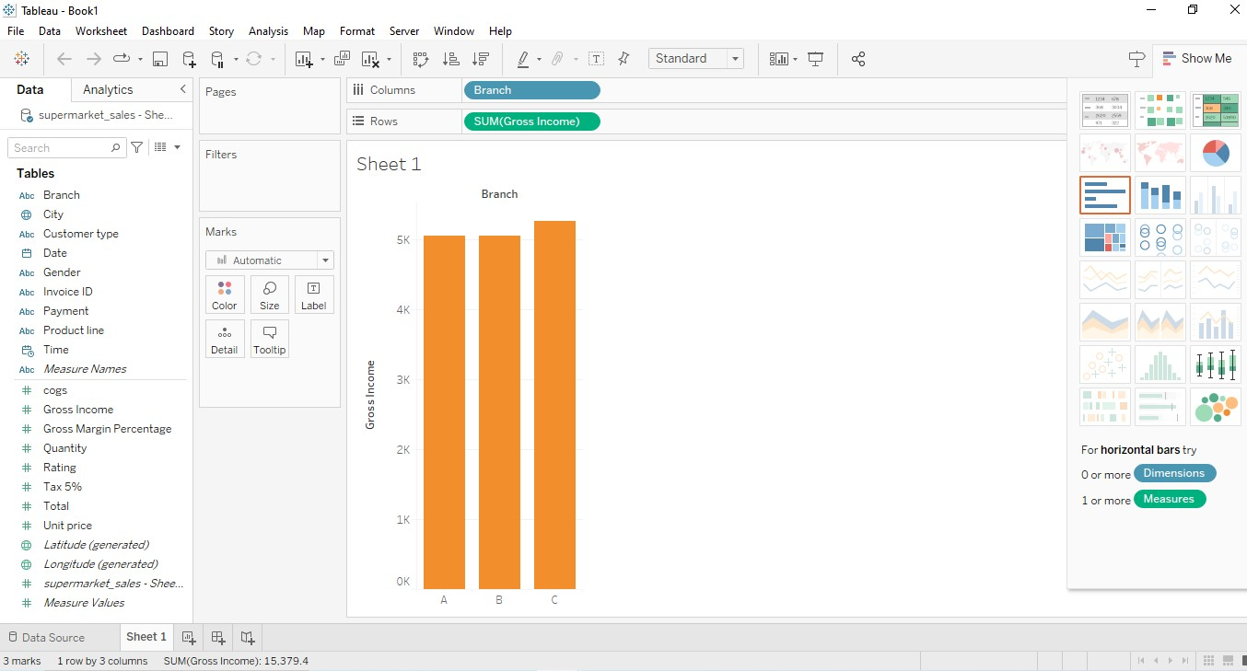

2.PIE CHART

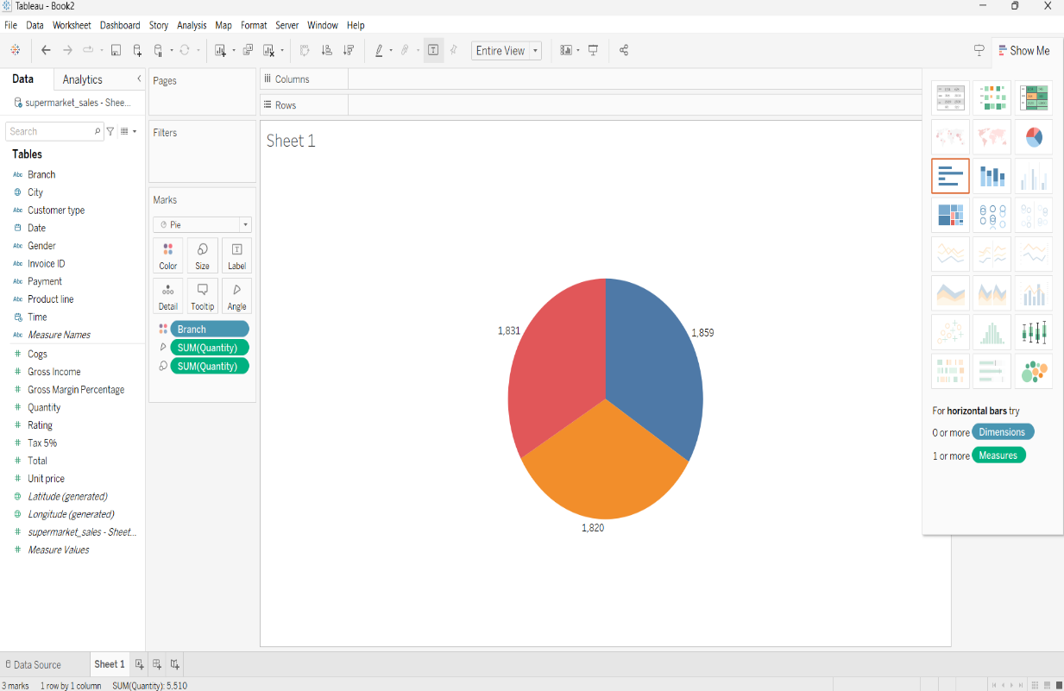

3.STACKED BAR CHART

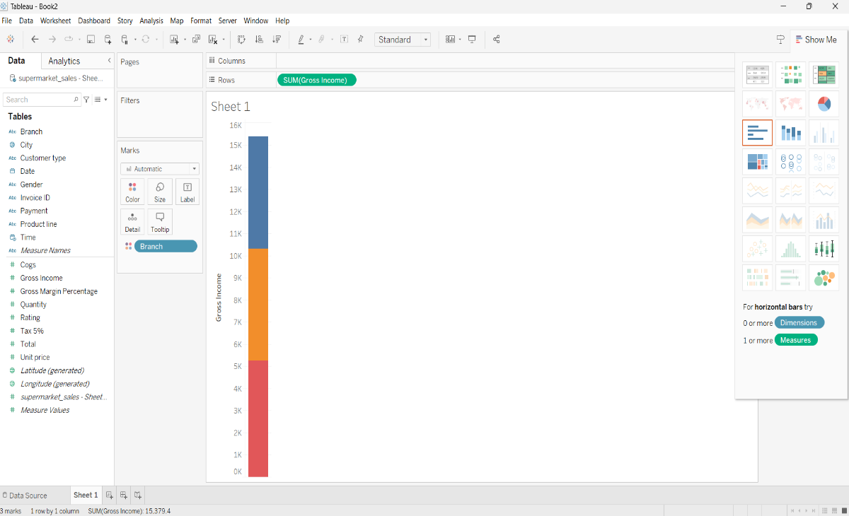

4.LINE CHART

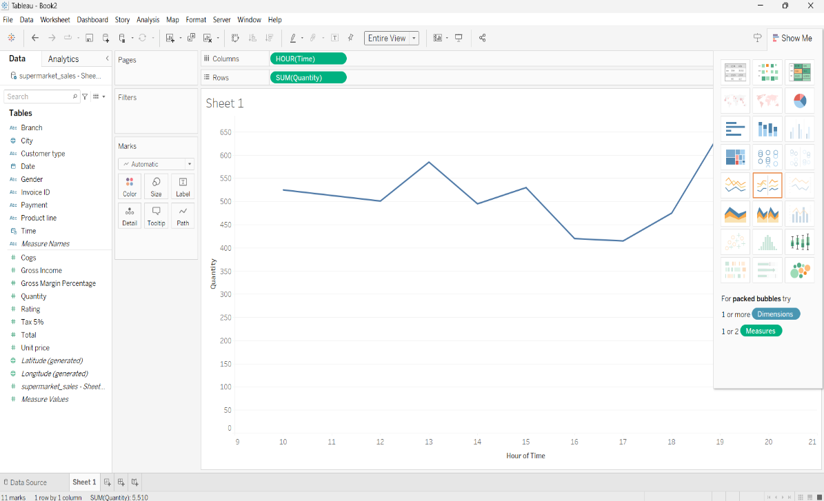

5.BUBBLE CHART

